**DAILY ONLINE ACTIVITIES SUMMARY**

|  |  |  |  |  |  |  |  |  |
| --- | --- | --- | --- | --- | --- | --- | --- | --- |
| **Date:** | **8-6-2020** | | | | | **Name:** | **Pavana P** | |
| **Sem & Sec** | **6A** | | | | | **USN:** | **4AL17CS057** | |
| **Online Test Summary** | | | | | | | | |
| **Subject** | | **CNSC** | | | | | | |
| **Max. Marks** | | **60** | | **Score** | | | **25** | |
| **Certification Course Summary** | | | | | | | | |
| **Course** | **Build an IOTS Blockchain Network for a supply chain.** | | | | | | | |
| **Certificate Provider** | | | Cognitive classes | | **Duration** | | | 4 hours |
| **Coding Challenges** | | | | | | | | |
| **Problem Statement:**  1.Write C++ program to Check whether a number can be represented as difference of two squares  2. C Program to Generate All the Set Partitions of n Numbers Beginning from 1 and so on  3. Java program to delete a node from the middle of the singly linked list  4. Program program to find whether a string is a palindrome or not | | | | | | | | |
| **Status: Completed** | | | | | | | | |
| **Uploaded the report in Github** | | | | | **YES** | | | |
| **If yes Repository name** | | | | | **DAILY STATUS** | | | |
| **Uploaded the report in slack** | | | | | **YES** | | | |

.

**Online Test :**

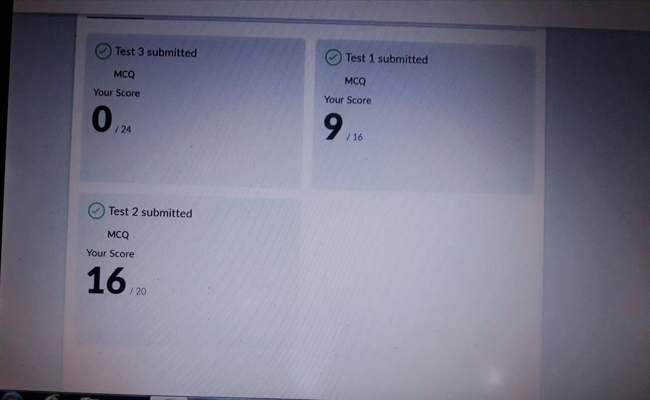Subject:-CNSC

**Certification Course Details:**

**Build an IOT Blockchain network for a supply chain :**

Today I have completed these topics:

1.Enable cloud applications to intercept particle function callbacks.

2.Set up the cloud electron Asset tracker .

3.Particle function callbacks.

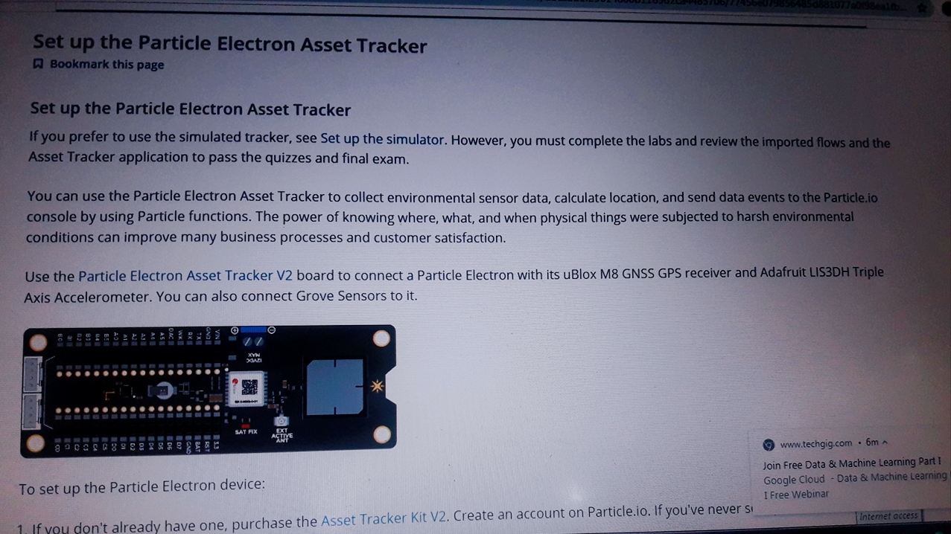

.

**Coding Challenges Details:**

**https://github.com/pavana-p-kulal/DAILY-STATUS/tree/master/8-6-20/Online%20Coding**